**Implementation of a 3D Scanner Arm**

Walker Arce1,2, James Pierce III1, Jorge Zuniga PhD1

**1**Department of Biomechanics, University of Omaha, NE, USA

**2**Department of Electrical and Computer Engineering, University of Omaha, NE, USA

**Abstract**

Three-dimensional scanning technology has reduced dramatically in price and ease of implementation. Unfortunately, these low-cost, three-dimensional scanning systems lack intuitive tracking during the scanning of a part. This leads to issues with mesh alignment during scanning, inaccuracies in the completed mesh and additional time to scan completion. This is problematic, especially when dealing with human subjects, where fatigue and impatience become a problem for the completion of a stationary scan. To address this, we have developed a low-cost, simple to use, and repeatable apparatus which rotates any scanner or camera about the central axis of the part being scanned.

**Introduction**

Historically, the production of sockets for prostheses and orthoses has been an involved process that requires clinician intervention in the molding, casting, and fitting to the residual limb [1]. The consequence of this process is high expense and long turn around time, resulting in ineffective prosthesis prescription especially in recent amputees whose training with a prosthesis is crucial immediately after injury [2]. To address these issues, the implementation of recently emergent technologies, such as 3D scanning and additive manufacturing, has been experimentally and clinically applied to stream line this process [1], [3]. In general, these studies have either relied on complex, expensive, and difficult-to-implement scanning and manufacturing technologies which limited their applicability in the clinic or used extremely low cost and low-quality equipment which led to questionable applicability [4-6].

The purpose of this present investigation is to create a stable platform for low-cost 3D scanners which eliminates reliability concerns in the production of accurate additively manufactured sockets for use in prosthetic and orthotics.

**Methods**

*Design and Production of 3D Scanning Apparatus*

The physical layout and design of the 3D scanning apparatus will be performed using Autodesk’s Fusion 360 computer-aided design (CAD) package. The primary design requirement of the proposed apparatus is the reliable rotation of a three-dimensional scanner about the longitudinal axis of a subject’s upper limb at a variable distance and speed.

To accomplish this goal, a high-torque (3 Nm) NEMA 23 stepper motor will be employed to drive the motion of the scanning system. One common 3D scanning device is the Sense 3D Scanner (3DSystems, Rock Hill, SC), which weighs 590 grams and produces a maximum moment of 2.3 Nm at its ideal scanning distance (40 cm) for objects of comparable size to residual limbs. Though the selected stepper motor is able to meet the torque requirements of the application, a greater factor of safety is desired to allow for manufacturing tolerances and operator errors.

To counteract the high inertial mass of the 3D scanner, the motor will be located on the opposite side of the limb’s longitudinal axis, allowing for more even distribution of mass and lower motor torque requirements. Placing the motor’s mass (1.8 kg) 13.5 cm to the opposite side of the rotational axis, the torque requirements for rotating the scanner are completely negated by the motor’s opposing torque (2.4 Nm). The only remaining torque required is that which is needed to move the arm the 3D scanner is mounted to about the rotational axis. For this reason, a lightweight composite (fiberglass) structural arm will be utilized to minimize inertial mass of the system.

To allow for smooth rotation about the residual limbs of subjects, a gear reduction using a planetary gearset will be employed in the transmission of motor power. Because the maximum average forearm diameter is 7.73 cm [a], a central hub opening of at least 8 cm is preferred so that most individuals will be able to use the apparatus. Based on this hub diameter, a likely gear ratio for the system is 89:18.

Once the design of the apparatus is complete, a prototype model will be produced using additive manufacturing (Ultimaker 2+ Extended, Ultimaker, Geldermalsen, Netherlands) with polylactic acid (PLA) plastic material for enhanced surface hardness and wear resistance. Models will be produced with a minimum infill percentage of 35% for sufficient strength.

*Creation of a Custom Control System*

To fulfill the requirements of this study, a custom printed circuit board will be designed in the EAGLE EDA package from Autodesk. This system will need to be able to control the NEMA 23 stepper motor that drives the gearing of the arm as well as accept input from the user’s computer in order to configure the system. Possible configuration changes would be altering the rotations per minute (RPM) of the motor to accommodate scanner quality. For instance, a lower quality scanner may need a slower RPM to capture a similar mesh density to a higher quality scanner.

In addition, the integrated motor driver will require thermal relief and careful design to ensure that the high current of the motor will not overheat the driver chip, causing the motor to stop in its rotation and the system failing. This behavior is mainly characterized by the current limiting of the chip, which is where careful consideration of the calculations is necessary [7]. To calculate the maximum current of the motor coils the following equation is used:

And when solved for the reference voltage (), becomes:

By incorporating a trim potentiometer into the voltage reference pin of the motor driver, we can dynamically change this and tune it to suit our motor. The only dependent parameter is which is the current sensing resistor used in the design of the motor driver. This will normally be in the range of milli-Ohms ().

The implemented power supply should be capable of supplying both the motor driver and motor, but also the supporting microcontroller circuitry and active cooling elements. Motor drivers and motors can normally operate on voltages in the range of 12V – 24V if not higher, so a wall plug power supply is suitable if it can deliver the currents necessary, which can be in the range of 1A – 3A. The microcontroller implemented should have a USB interface to allow for the configuration changes to be applied, as well as enough input/output pins to drive the multiple pins of a motor driver. Finally, the active cooling elements used are a set of push/pull fans that are mounted on both sides of the housing to pull heat out of the interior chamber of the scanner arm.

The mentioned elements are characterized in the block diagram shown, which shows the control flow of the system, with the output being the stepper motor actions. At this point in time, no considerations were made on the ability to interface with a scanner through this system, as the complexity faced with integration of multiple scanners would be outside the scope of this study. The interfacing of the scanner is handled by the user’s PC with a separate USB port.

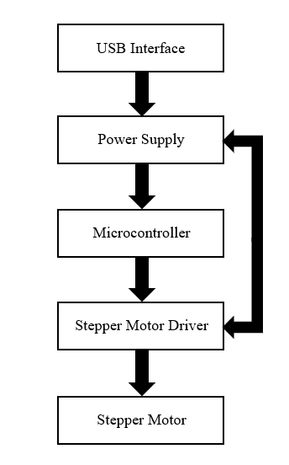

*3D Scanning Paradigm for Residual Limbs*

All testing and future use of the produced 3D scanning apparatus will follow a standardized and repeatable procedure.

After comfortably seating a subject at a table of height 29-33 inches, the arm to be scanned will be rested in an armrest integral to the 3D scanning apparatus. Hook-and-loop fabric (i.e. Velcro) will be used to stabilize and secure the limb for repeatable scanning. If the subject has fingers, they will be asked to extend them in a position which they can retain for at least thirty seconds. Once properly positioned, the scanning process will be started from the 3D scanner’s associated software, and the serial monitor of Arduino’s IDE programming environment will initiate rotation of the scanner arm at a selected rate of rotation (between one and 12 RPM). The 3D scanner will then make two full revolutions around the subject’s residual limb, in counterclockwise and clockwise directions, respectively.

Once scanning has been completed, the resultant mesh will be healed and processed withing the scanning software, and exported for use in the development of custom sockets for fitting.

**Results**

*3D Scanner Arm*

The completed design for the 3D scanning apparatus comprises a central hub of 9.5 cm diameter, with a planetary gearset isolating it from the motion of the scanner assembly. Dovetail mating geometries allow for easy assembly of the various components. Self-retaining of the planetary gearset was obtained through the use of a custom-designed herringbone gearset, which was printed in place, with no assembly required. (Figure X)

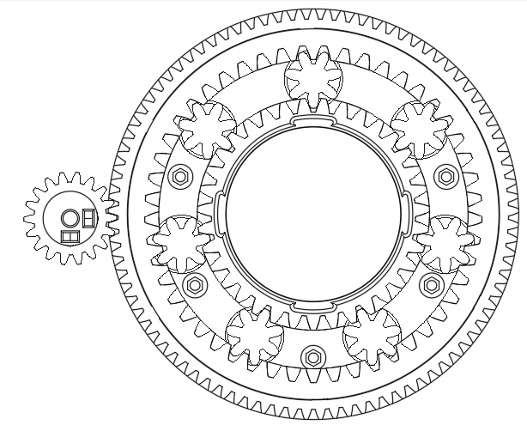

The motor mount was designed such that the NEMA 23 stepper motor was 13.5 cm from the central axis, in accordance with earlier torque requirement calculations. The Sense 3D Scanner was attached to the apparatus via structural fiberglass I-beam of mass 0.899 kg. A sliding mount for the scanner was attached to the arm and fixed in place with an M5 set screw. The 3D scanner was attached to this mount through the use of its standardized 1/4”-20 threaded attachment geometry. (Figure X)

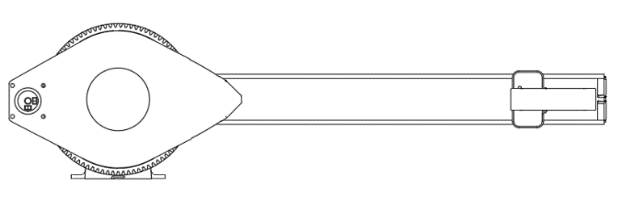

Once printed, the apparatus was affixed to the testing bench using wood screws. A tall, adjustable height chair was used to make subjects comfortable and naturally positioned. All motion components were packed with PTFE grease, to allow smoother and quieter operation.

*Custom Electronic Control System*

The designed control system was able to fulfill the requirements of the study. The integrated motor driver runs with very limited heating when driving the scanner arm. It has a small enough footprint to be integrated into a small housing chamber that increases the efficiency of the cooling and the cost of the system is under thirty USD.

The thermal considerations for the design were implemented within the specification of the datasheets provided by Allegro Microsystems [7], as the A4988 motor driver was used. This incorporates 68mΩ sense resistors with a 10kΩ to adjust the motor coil current. The A4988 is controlled u sing an ATmega32u4RC USB microcontroller from Microchip which not only incorporates the USB interface required but also twenty-six input/output lines [8].

By following the datasheet specifications for the A4988, a thermally resilient design was realized as shown in figure XXX [7].

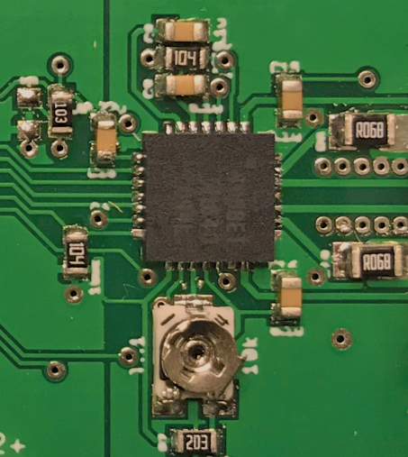

Similarly, by following the specification for the ATmega32u4, a reliable and repeatable design was realized that is optimized for the space that it was designed in [8]. This is shown in figure XXX.

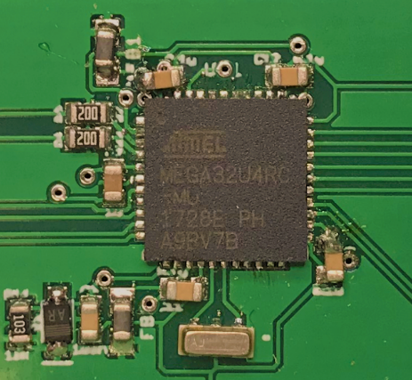

The overall system is shown, including the 5V regulator, screw terminal block for power input as well as power output for the active cooling fans. The programming pins of the ATmega32u4 can also be seen along with USB interface and stepper motor connector.

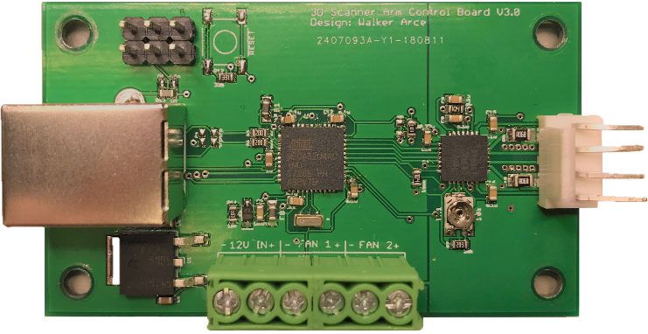

*Testing of the Apparatus*

Testing was performed using a stand-in for a human subject, simulating a forearm and hand without fingers. Scanning took place at 8 RPM, and two full rotations about the simulated residual limb were performed before the scan completed.

Results of the procedure appear promising, as the scan required no user intervention and produced repeatable results. Each scan took approximately 30 seconds, which is significantly faster than other comparable methods [sources here].

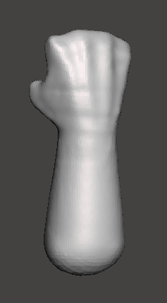

Volumetric comparison of scans obtained at varied speeds (2, 4, 6, 8, 10, 20, 30, 40 and 50 RPM) at a fixed distance revealed consistency in the quality and relative accuracy of the produced meshes. In general, no measure differed from the mean volume (434.16 ± 19.61 cm3) by more than 6.13%, which occurred only at the highest speed of 50 RPM. This indicates that the apparatus is both repeatable and accurate in its model creation.

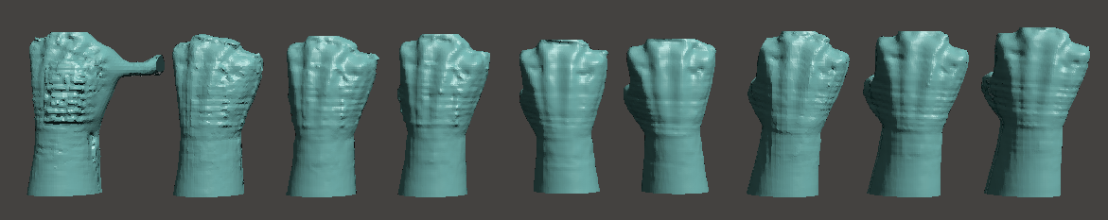

|  |  |  |
| --- | --- | --- |
| **RPM** | **Volume** | **% Difference** |
| 2 | 456.46 | 5.135548066 |
| 4 | 441.32 | 1.648381178 |
| 6 | 452.27 | 4.170473478 |
| 8 | 424.22 | -2.290228716 |
| 10 | 405.81 | -6.530568373 |
| 20 | 431.83 | -0.537432149 |
| 30 | 414.16 | -4.607329039 |
| 40 | 420.62 | -3.119409746 |
| 50 | 460.78 | 6.130565302 |

**Discussion**

The main drawback of the designed control board is the incorporation of a trim potentiometer to adjust the current of the motor coils. This could have been implemented through the microcontroller’s ability to generate pulse width modulation (PWM) signals to allow for on-the-fly current adjustments which would not only accommodate motors with different current requirements but also allow for the motor current to be increased at the apex of the circular movement to increase the holding torque. By doing this, the motor would be less likely to skip steps from the increased moment arm generated by the weight of the scanning apparatus throughout its travel circumference. By then reducing the current once this point is passed, the hazard of the increased current creating enough thermal mass to cause the system to fail is mitigated.

One limitation of the mechanical design is the physical routing of the wires for the NEMA 23 stepper motor. By using the motor as a counterbalance, the wires were then forced to be housed outside the rest of the assembly and floated freely. In general, this was not problematic, but did lead to anomalous mesh bodies during faster scans which required additional post-processing. Future designs would benefit from static motor mounting to mitigate this issue.

The scope of the test scans produced for this research was limited; rather than testing on a human subject, a simple simulator for an amputee’s residual limb was used. This made repeatability easier by eliminating variability in subject arm placement.

In general, the novel 3D scanning apparatus developed for this study shows promise for the enhancement of low-cost residual limb models. Inconsistencies in the stitching of meshes were rectified by the repeatability and smoothness of scanner trajectories about the simulated residual limb, and scanning times were drastically reduced compared to comparable methods. Operation of the apparatus was simple, and made easily compatible with the existing 3D scanning workflow, allowing for seamless integration into the simulated clinical setting.

Future research relating to this apparatus will focus on the optimization of scanning speed, testing on human subjects, and redesigning for use in lower-limb amputees.

**Acknowledgements**

**Funding Received**

This research was supported by the Autodesk Student Fellowship and the NASA Nebraska Student Fellowship.

**References**

[1] Rosicky, Jiri, et al. “Application of 3D Scanning in Prosthetic and Orthotic Clinical Practice.” Proceedings of the 7th International Conference on 3D Body Scanning Technologies, Lugano, Switzerland, 30 Nov.-1 Dec. 2016, 2016, doi:10.15221/16.088.  
[2] Krebs, D. E., Edelstein, J. E., & Thornby, M. A. (1991). Prosthetic management of children with limb deficiencies. Physical therapy, 71(12), 920-934.  
[3] Jin, Yu-An, et al. “Additive Manufacturing of Custom Orthoses and Prostheses – A Review.” Procedia CIRP, vol. 36, 2015, pp. 199–204., doi:10.1016/j.procir.2015.02.125.  
[4] Commean, P. K., Smith, K. E., & Vannier, M. W. (1996). Design of a 3-D surface scanner for lower limb prosthetics: a technical note. J Rehabil Res Dev, 33(3), 267-78.  
[5] Comotti, Claudio, et al. “Low Cost 3D Scanners Along the Design of Lower Limb Prosthesis.” Proceedings of the 6th International Conference on 3D Body Scanning Technologies, Lugano, Switzerland, 27-28 October 2015, 2015, doi:10.15221/15.147.  
[6] Buffa, Roberto, et al. “A New, Effective and Low-Cost Three-Dimensional Approach for the Estimation of Upper-Limb Volume.” Sensors, vol. 15, no. 6, 2015, pp. 12342–12357., doi:10.3390/s150612342.  
[7] Allegro Microsystems, “DMOS Microstepping Driver with Translator And Overcurrent Protection”, A4988 datasheet, Jan. 2012 [Revised May 2014]  
[8] Microchip, “8-bit Microcontroller with 16/32K bytes of ISP Flash and USB Controller”, ATmega32u4 datasheet, Aug. 2007 [Revised April 2016]

[a] Anakwe, R. E., Huntley, J. S., & McEachan, J. E. (2007). Grip strength and forearm circumference in a healthy population. Journal of Hand Surgery (European Volume), 32(2), 203-209.